Emma Beers
Placement: Florida Christian School
Class: 6th Grade Treble Chorus

IMPACT PROJECT report

introduction:
My impact on student learning began with the end goal in my mind. I aimed to build upon the 6th grade treble chorus class’ knowledge of solfege and theory to strengthen their approach in rhythmic and melodic dictation exercises. As someone who was not exposed to melodic dictation until I reached college, I was determined to introduce a consistent method that students could implement when approaching rhythmic and melodic dictation exercises. Due to the fact that the students already possessed previous exposure to solfege, I was able to build upon this foundation to create a simplified step-by-step strategy to assist them during aural dictation. After administering a pre-test requiring students to demonstrate their preexisting knowledge, I was able to create 3 unique 30 - minute lesson plans that I taught over the course of 3 separate class periods. Each lesson introduced a different element to help strengthen students’ dictation skills. Based on my results of the pre-test I was able to identify exactly what the student’s needed improvement on: pitches to solfege relationship, staff notation, and strengthening their understanding of rhythmic structure.

THE TEST & THE GOALS:
My overarching instructional goal was to introduce my method so that the students could implement the method and result in improvement of the post-test score results. The pre-test consisted of 10 questions: 5 rhythmic dictation exercises and 5 melodic dictation exercises. I remained within the parameters of C - major, 3 / 4, 4 / 4 time signatures, quarter notes/rests, half notes, and whole notes only. The students were given 3 listens on each rhythmic exercise, 3 listens on questions 6-7 of the melodic section, and 4 listens on questions 8-10 of the melodic section. Each question was worth one point, and the entire question was marked incorrectly even if one note was identified or incorrectly placed.

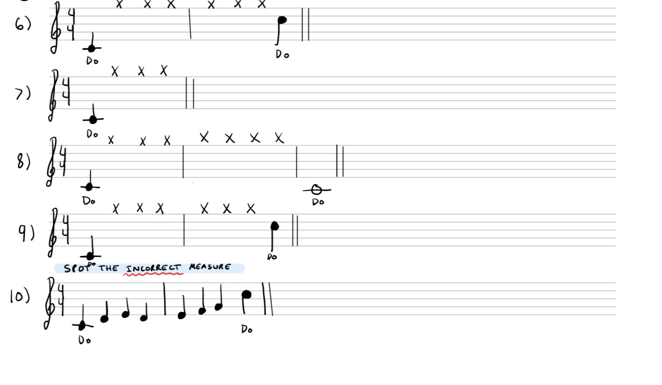
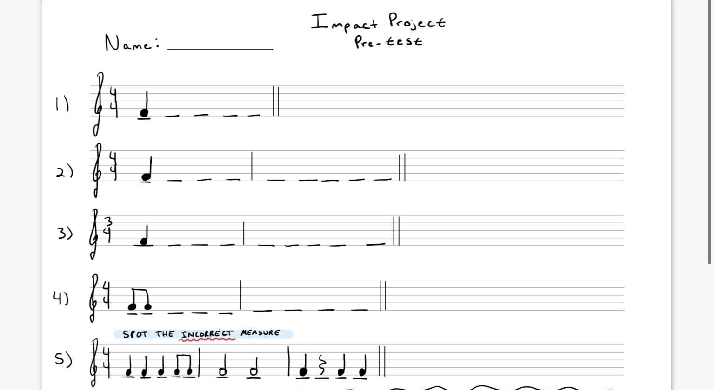
Questions 6-9 required students to listen to a short melody I played on the piano. Question 10 required students
to identify the measure that was played incorrectly.
Questions 1-4
required students to
listen to a series of
notes and identify
the rhythm I played
on the piano. Question
5 required the students
to identify the measure
that was played incorrectly.

.

lesson titleS: |  | FLORIDA STATE STANDARDS: | Objectives:
- “Intro to Melodic Dictation”  - “Intro to Staff Notation”  - “Intro to Rhythmic Notation” |  | MU.68.S.1.4 Sing or play melodies by ear with support from the teacher and/or peers.  MU.68.S.3.5 Notate rhythmic phrases and/or melodies, in varying simple meters, performed by someone else.  MU.68.S.3.4 Compare written notation to aural examples and analyze for accuracy of rhythm and pitch. | - - SWBAT utilize solfege to decipher C – Major, one bar, step-wise,  and/or arpeggiated skips in melodic aural skill dictation exercises.  - SWBAT improve music theory notation in melodic dictation.  - SWBAT dictate short melodies either sung or played.  --------------------------------------------------------------------------------------------------------------------  - - SWBAT differentiate between staff lines and spaces.  - SWBAT differentiate between interval steps and skips on the staff.  - SWBAT identify solfege in C-major (4 /4 or 3 / 4-time signatures) and write in the corresponding notes by looking or listening to a melodic line.  - SWBAT complete a melodic dictation with only 3 listens (following the 3-step approach)  --------------------------------------------------------------------------------------------------------------------  - -SWBAT utilize the note tree to identify notes and their corresponding values.  -SWBAT utilize the “Ta-Ti” rhythm system to identify which exercise I played on the piano.  -SWBAT identify which rhythmic exercises’ I played incorrectly on the board.  -SWBAT write in the rhythm using the “Ta-Ti” system after I play the exercise on the piano.

INTERACTIVE/ENGAGING ACTIVIES:
In order to achieve my goals of increasing the students’ familiarity of essential music theory concepts and to raise their test scores, while increasing their skills in rhythmic and melodic dictation; each lesson had a corresponding activity that involved a different type of assessment.

- Lesson 1 “Intro to Melodic Dictation” consisted of a whole-class activity in which the students were given a 5-question worksheet to complete as a class. The students were given a quick presentation introducing a “3-step method” to follow before beginning a dictation exercise: identify the key signature, time signature, and the solfege. As a class, we discussed and practiced identifying these components with various examples before proceeding to the in-class activity, where I played the exercises on the piano, the students sang back the pitches on solfege and completed the dictation as a group. (The main goal of this lesson is for students to begin to formulate a connection between played melodies and solfege.)
WORKSHEET - >
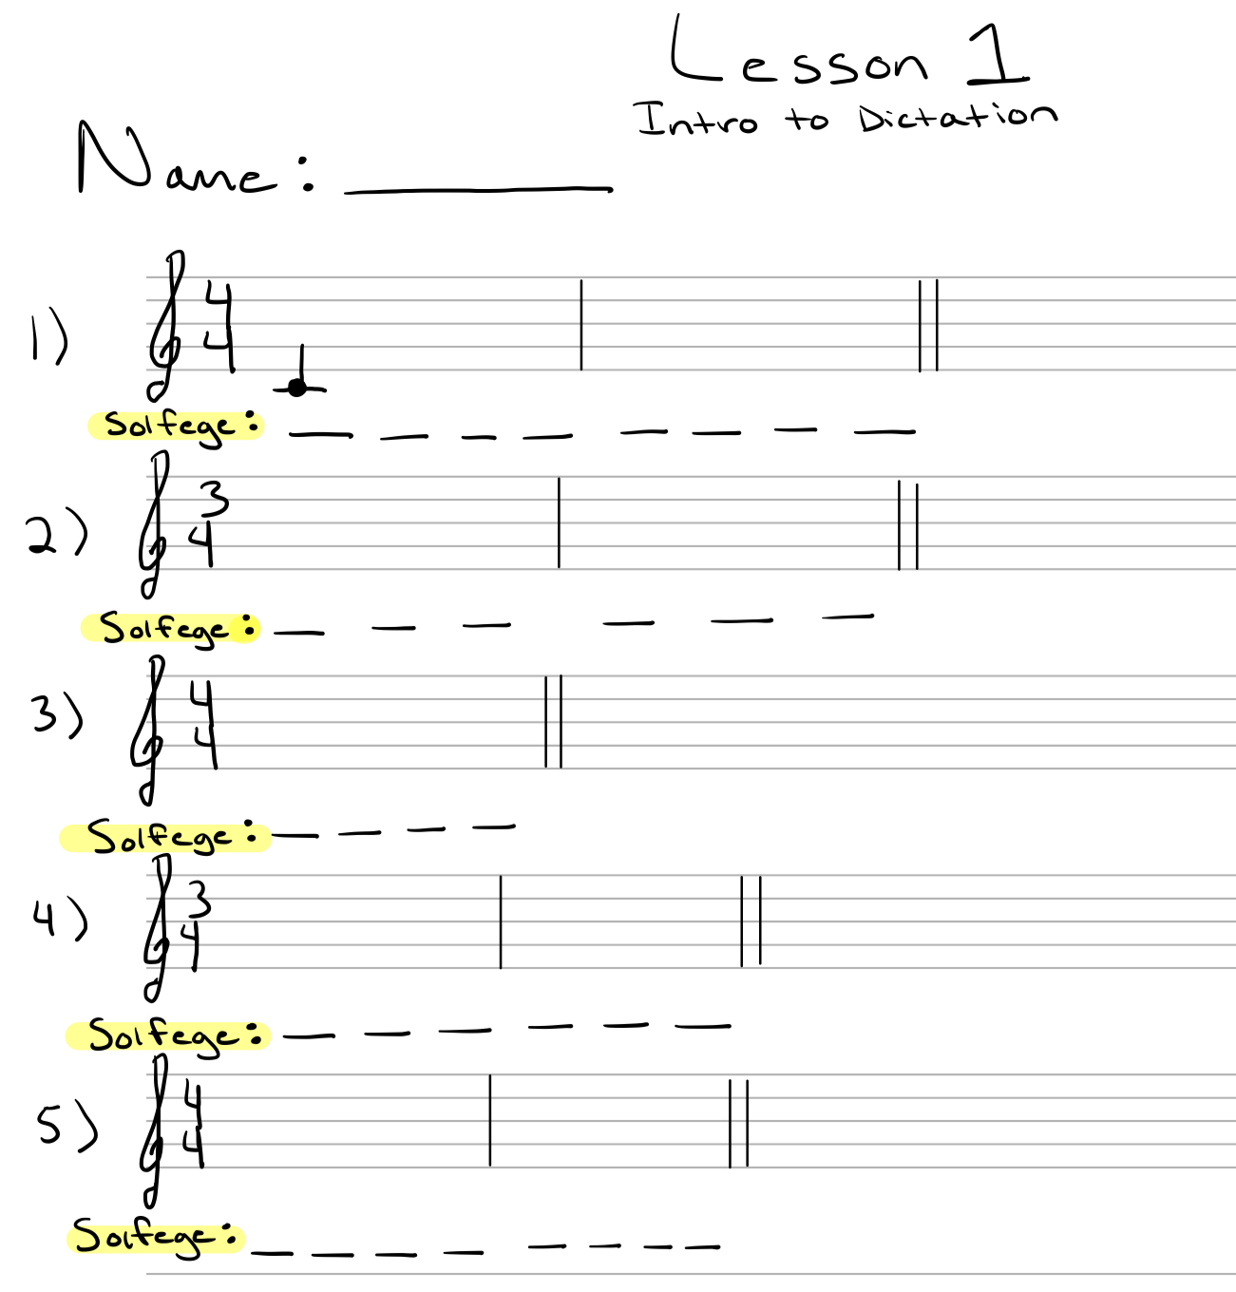

- Lesson 2 “Intro to Staff Notation” consisted of a class discussion and review of staff lines, spaces, and interval steps vs skips. The students
participated in a whole-class activity as individuals volunteered to come to the board to answer a question about staff lines, or interval steps vs.
skips. They were asked to follow the procedure of circling steps and underlining skips in each exercise. As a class we completed an activity in
which the students listened to the melody and practiced implementing the correct staff notation, and identifying the corresponding solfege,
and circling steps, underlining skips in their completed exercise.
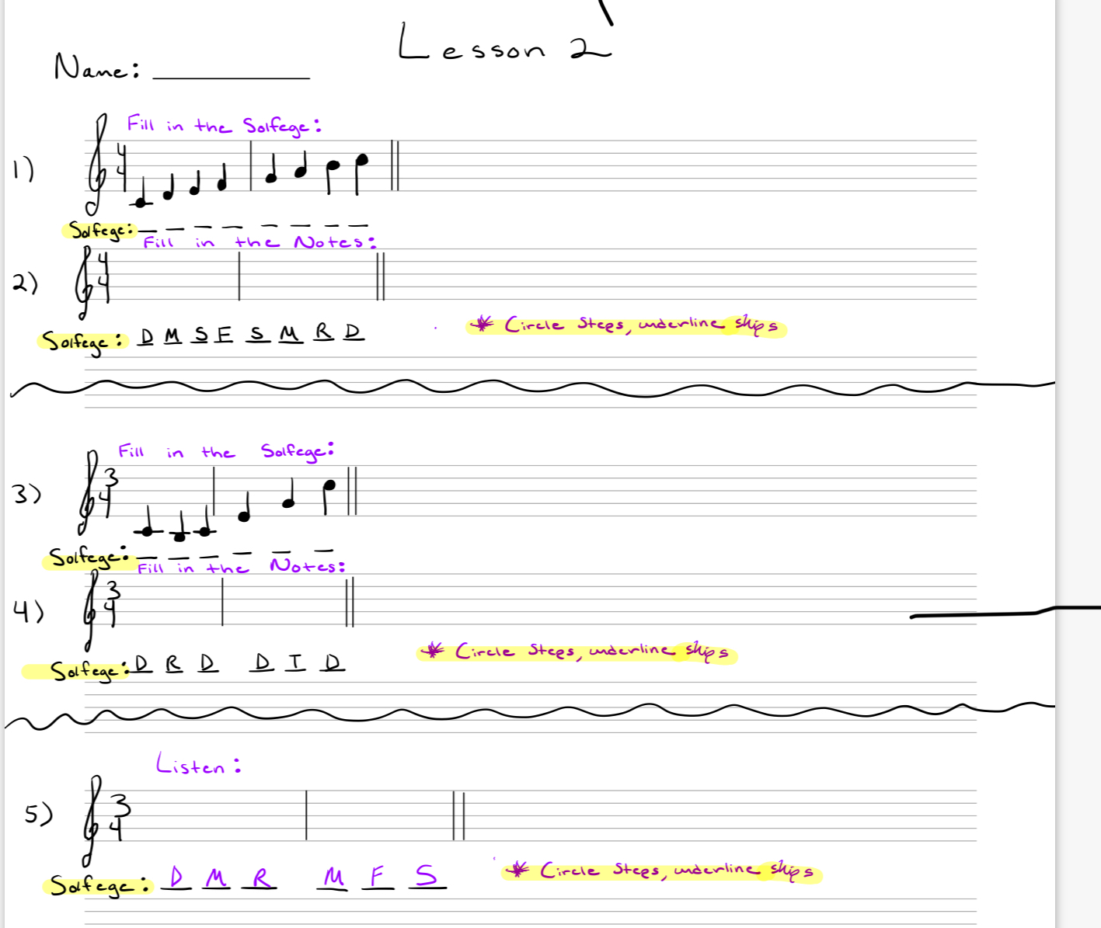
WORKSHEET - >

- Lesson 3 “Intro to Rhythmic Dictation” consisted of an introduction to the “Note and Rhythm Tree.” I taught the students the relationship
between each note and its value. We reviewed this a class and how the held notes sounded in rhythmic dictation. I asked the students to
use their “Ta-Ti” system to practice the rhythm of each group of notes. Finally, I played the sequence of notes on the piano out of order and
asked the students to identify which group it was. I followed this example with more student-volunteered activities for students to each
have an opportunity to practice their rhythmic dictation using the “Ta-Ti” system and hearing the rhythm on the piano, and identifying the
correct exercise. We also completed a reversed activity, in which I asked the students to use their “Ta-Ti” to correctly identify the rhythm I played..
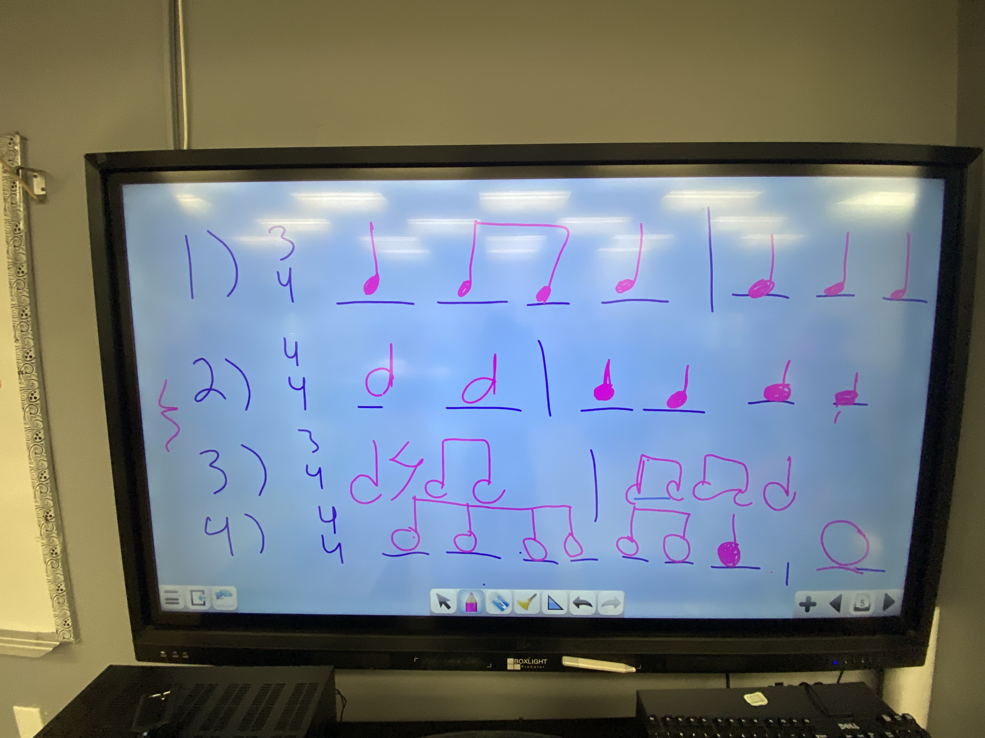
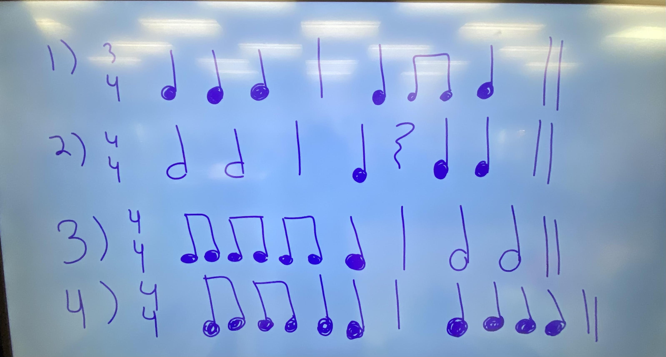
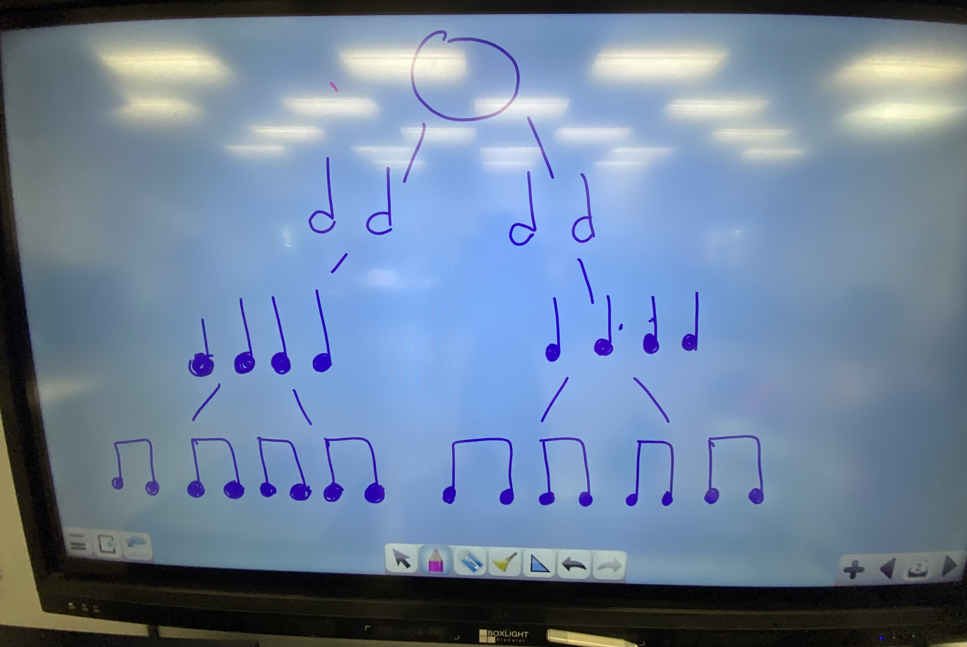

TEST RESULTS:
**13 students completed the whole test, 4 students completed only the rhythm section (due to a class schedule conflict),
3 students were absent the day of the pre-test, and 1 student was absent the day of the post-test.

PRE-TEST AVERAGE: 73.1% - (whole test) – 13 students
POST-TEST AVERAGE: 83.8% - (whole test) – 13 students

PRE-TEST AVERAGE: 82.4% - (rhythm section only) – 17 students
POST-TEST AVERAGE: 87% - (rhythm section only) – 17 students

PRE-TEST AVERAGE: 60% - (melodic section only) – 13 students
PRE-TEST AVERAGE: 70.8% - (melodic section only) – 13 students

PRE-TEST RESULTS | post-test results
Student Rhythmic: Melodic: TOTAL:  1) Hayden 5 out of 5 3 out of 5 8 out of 10  2) Olivia 2 out of 5 3 out of 5 5 out of 10  3) Amy V. 5 out of 5 3 out of 5 8 out of 10  4) Alyssa R. 5 out of 5 1 out of 5 6 out of 10  5) Jaylah 5 out of 5 5 out of 5 10 out of 10  6) Gianna V. 4 out of 5 4 out of 5 8 out of 10  7) Pearl 3 out of 5 0 out of 5 3 out of 10  8) Sarah E. 5 out of 5 3 out of 5 8 out of 10  9) Victoria 3 out of 5 3 out of 5 6 out of 10  10) Adri 5 out of 5 4 out of 5 9 out of 10  11) Alexandra 5 out of 5 3 out of 5 8 out of 10  12) Brianna 4 out of 5 2 out of 5 6 out of 10  13) Kaylee 5 out of 5 5 out of 5 10 out of 10  14) Bella B. 3 out of 5 3 out of 5 6 out of 10  15) Emma G. 2 out of 5  16) Nana 5 out of 5  17) Becky 5 out of 5  18) Aimee P. 5 out of 5 | Post-test: Rhythmic: Melodic: TOTAL:  1) Hayden 5 out of 5 5 out of 5 10 out of 10  2) Olivia 5 out of 5 3 out of 5 8 out of 10  3) Amy V. 5 out of 5 4 out of 5 9 out of 10  4) Alyssa R. 5 out of 5 2 out of 5 7 out of 10  5) Jaylah 5 out of 5 5 out of 5 10 out of 10  6) Gianna V. 5 out of 5 3 out of 5 8 out of 10  7) Pearl 5 out of 5 1 out of 5 6 out of 10  8) Sarah E. 5 out of 5 3 out 5 8 out 10  9) Victoria ABSENT ABSENT ABSENT  10) Adri 5 out of 5 4 out of 5 9 out of 10  11)Alexandra 5 out of 5 3 out of 5 8 out of 10  12) Brianna 5 out of 5 3 out of 5 8 out of 10  13) Kaylee 5 out of 5 5 out of 5 10 out of 10  14) Bella B. 5 out of 5 3 out of 5 8 out of 10  15) Emma G. 1 out of 5  16) Nana 5 out of 5  17) Becky 5 out of 5  18) Aimee P. 5 out of 5
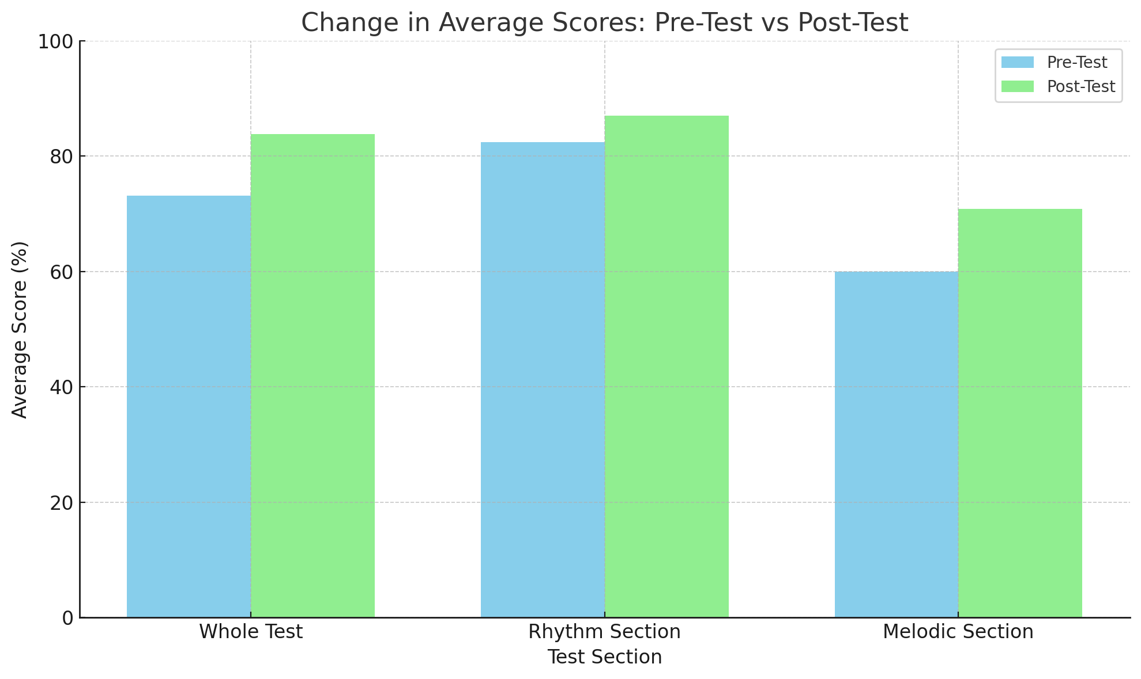

SCORE AVERAGE

GRAPHICAL

REPRESENTATION:

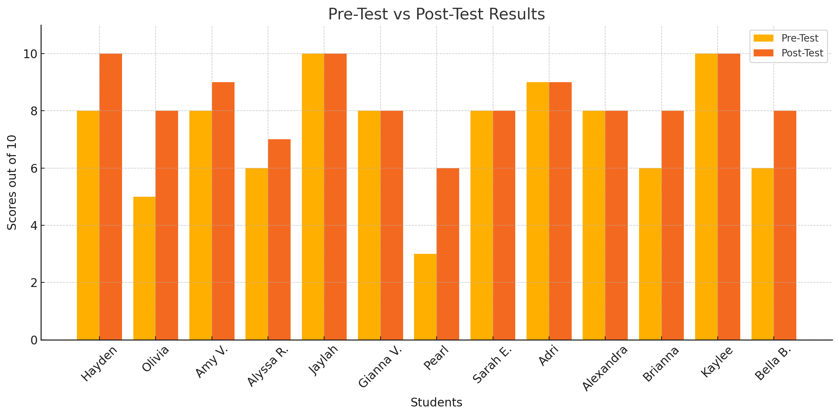

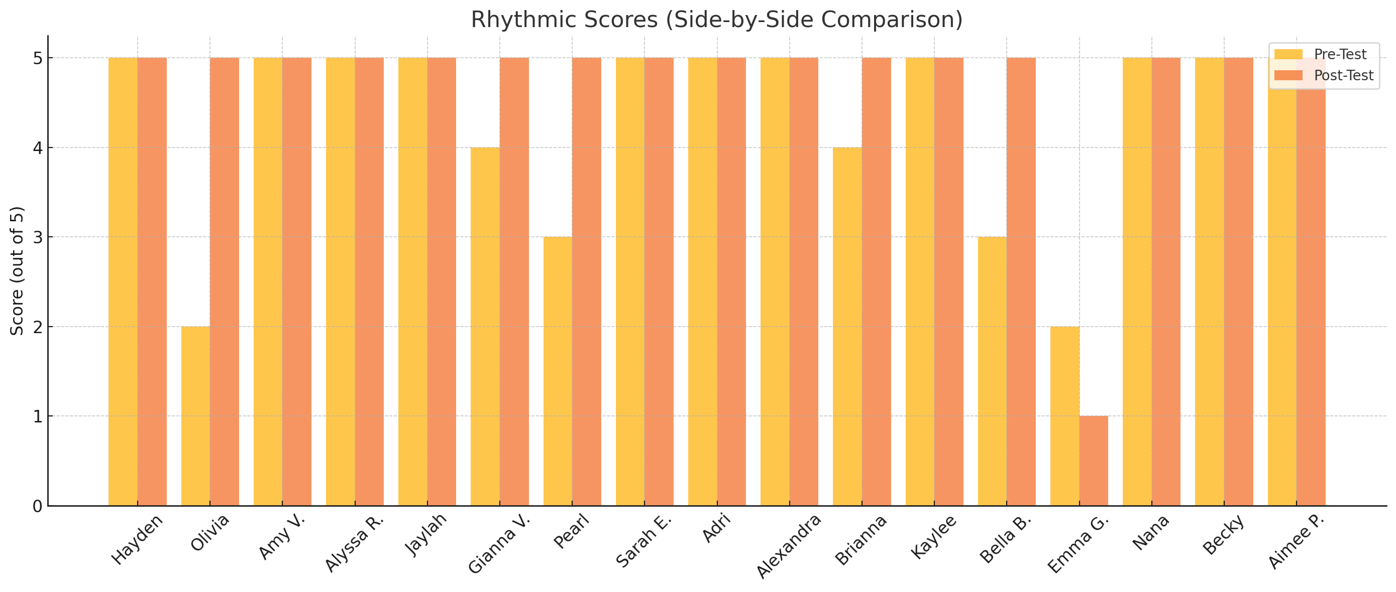

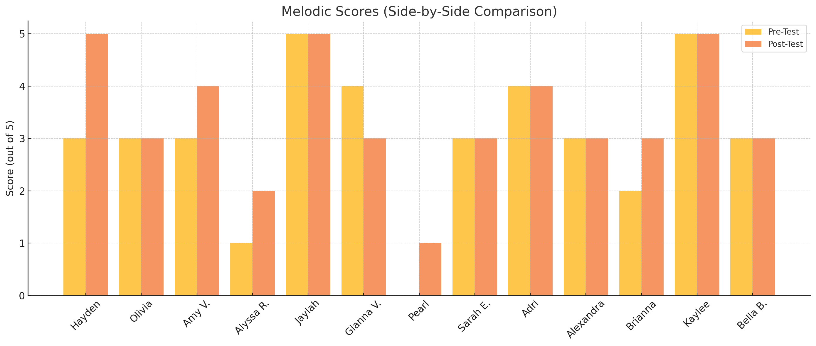

GRAPHICAL REPRESENTATION PER QUESTION:
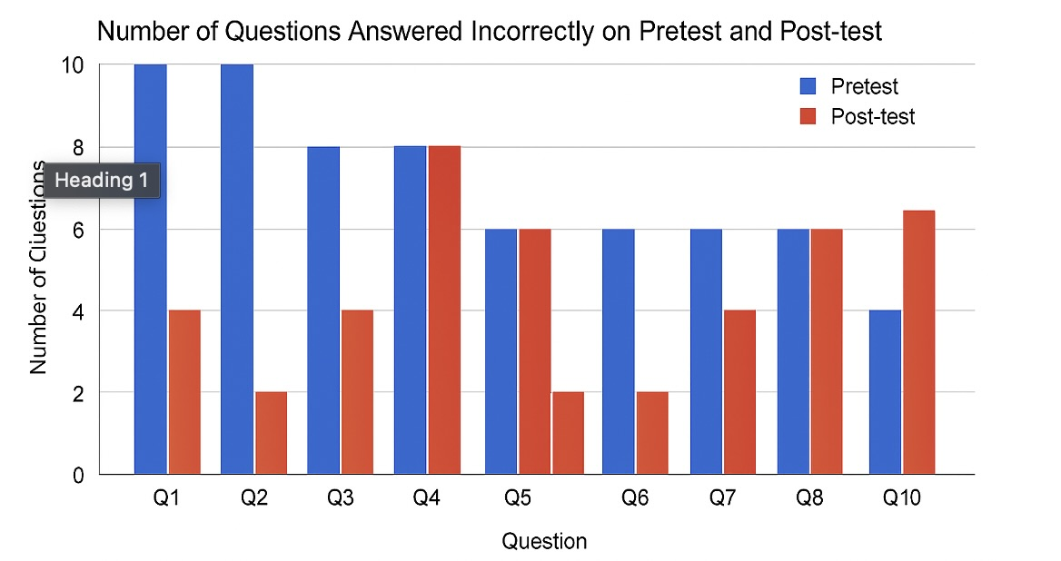

ACCOMODATIONS:
- Although I did not have any ELL students, I did have one student who receives extra time on tests and assignments.
Unfortunately, this student was not present on the day of the pretest, so they were not able to complete it. However, this student did
participate in the 3 corresponding lessons and would have been permitted to receive extra time on the worksheets if needed.

ANalysis:
- I was not at all surprised with the results of this data. As I was already aware of the 6th grade chorus’ previous knowledge of solfege and basic music theory, I knew that if I approached the daunting task of aural dictation by introducing a straightforward method, that the students would be able to increase their scores even just by a little bit. Based on the results of the 13 students who were able to partake in the entire pre-test and post-test, they increased their test score by 10.7%. Although it may not seem to be a large increase, I am confident that the students now have a method they can use to assist in rhythmic dictation, but most importantly melodic dictation. My main goal of introducing the relationship between played pitches using solfege, seemed to have assisted in the learning process.
- I must admit that I hoped the post-test average would have been a bit larger of an increase. I wish I would have taught the lessons within a smaller time frame, which may have resulted in a higher percentage increase. If I were to execute this task again, I would aim to teach the lessons in a closer time frame so that the steps and method I taught would be fresher for the students.

IMPACT ON student learning:
- I believe that although my impact on student learning may appear small on a data sheet, I believe that it was still significant. All of the
lessons I created involved interactive informal and formal assessments to allow me to track individual progress of student learning.
Although the 6th grade chorus is part of a feeder music program, there are quite a few of the students in the class that do not possess formal
music theory knowledge. I thoroughly enjoyed getting to work one-on-one with a few of the students and watch their progress, as well as
celebrating their small victories. Watching students that appeared lost and overwhelmed on the pre-test day, developed a little more confidence
on the day of the post-test. I could tell by the demeanor and energy of the classroom on the post-test day that the students seemed to
recognize these types of exercises and how to approach them. In the end, I never sought perfection, but I just wanted the students to start to
implement my method to simplify the complexity of aural dictation. And therefore, I believe I achieved that based on the students’ progress

influence ON future teaching:
-This project pushed me to think outside the box in order to achieve my goal of inventing a method to teach aural dictation to a 6th grade chorus class. I am proud of the strategy I created, and that it has the potential to be furthered developed into an even stronger sequence of lessons. I believe that these results provided a foundation for me to eventually create a larger series of lessons in the future. I quickly realized what was effective in my lessons, and what other instructional details I could have implemented to create even more engaging support for student learning. However, as previously mentioned, I could not be more grateful to watch a group of students boost their confidence while learning a college level music theory concept. I will never forget the reactions I received on the day of the pre-test in comparison to the reactions on the post-test day. Knowing that I have at least made some sort of impact on student learning during this process, allows me to view this experience as successful. I am very grateful to have utilized this experience to jumpstart and enhance my teaching in a classroom of my own.

